**Pre-Lab 8:**

**BJT Amplifier Configuration**

Name: Wan-Yu Liao

ECEN 325 Section 514

TA: Mandela

Date: October 25, 2019

**Calculation**

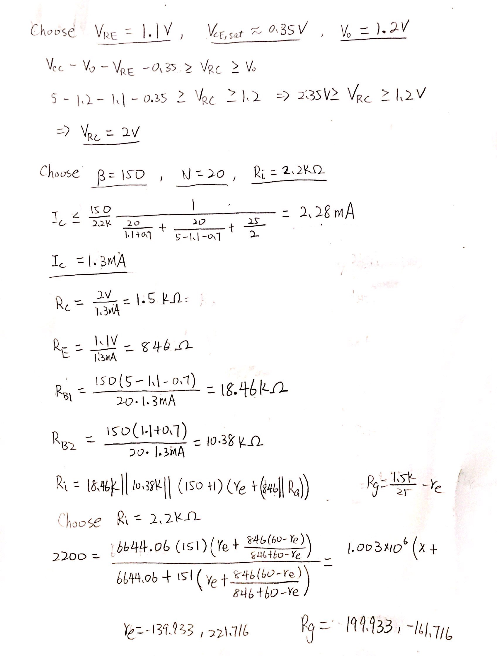

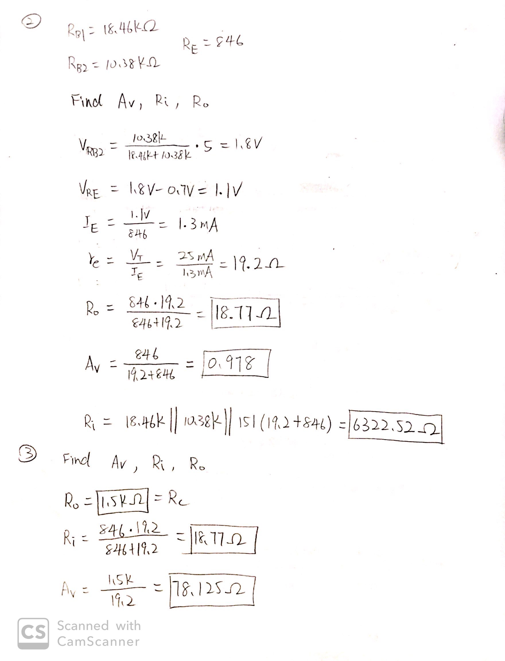

**Simulation**

**(1)**

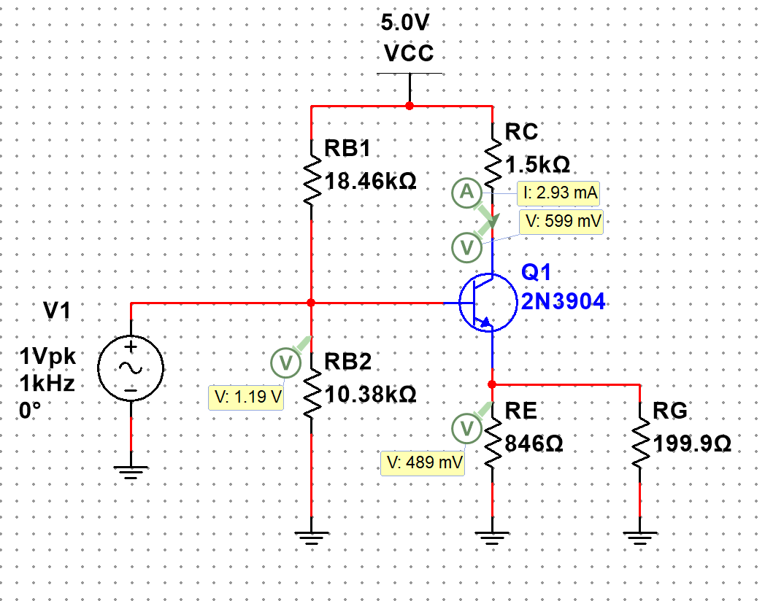

Figure 1: DC solution for Fig. 4(a)

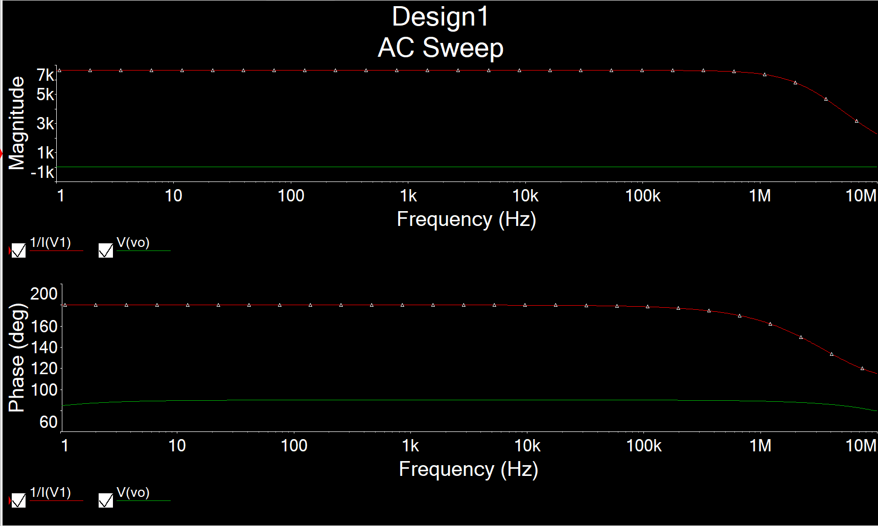

Figure 2: AC Simulation for Av, Ri and Ro for Fig. 4(a)

(Tried to find Av but couldn’t appear on the graph)

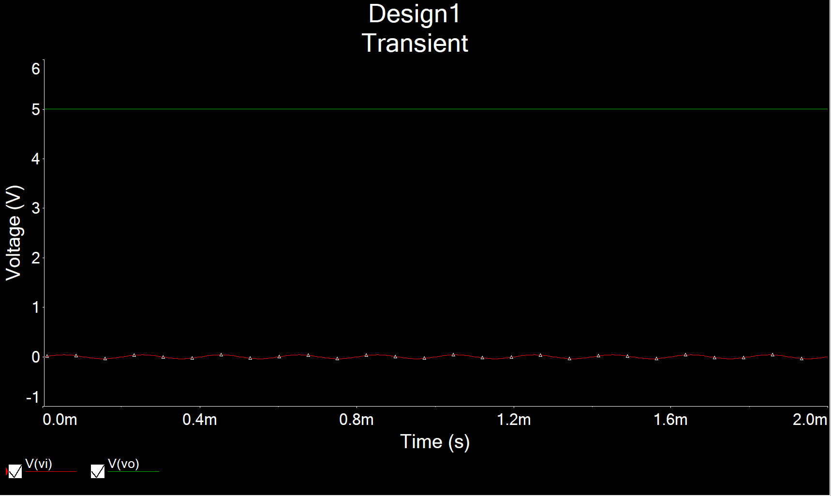

Figure 3: Time-domain Waveform for Fig. 4(a)

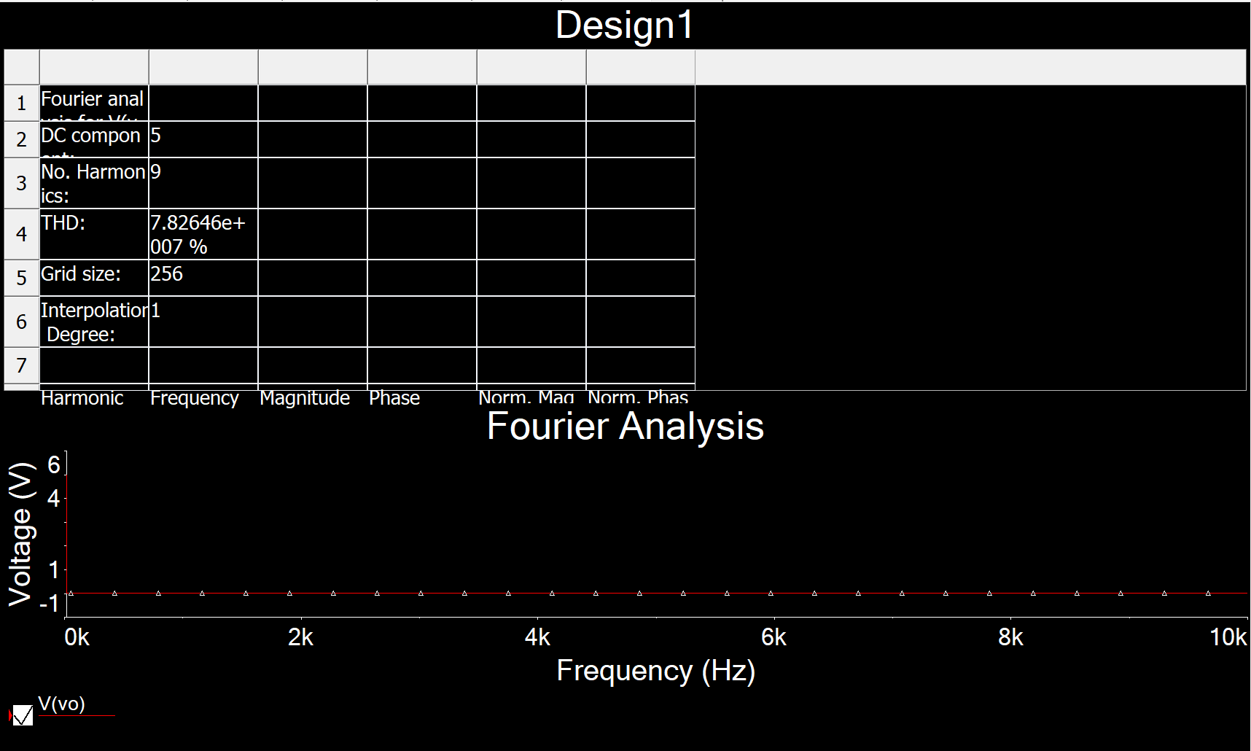

Figure 4: THD Waveform for Fig. 4(a)

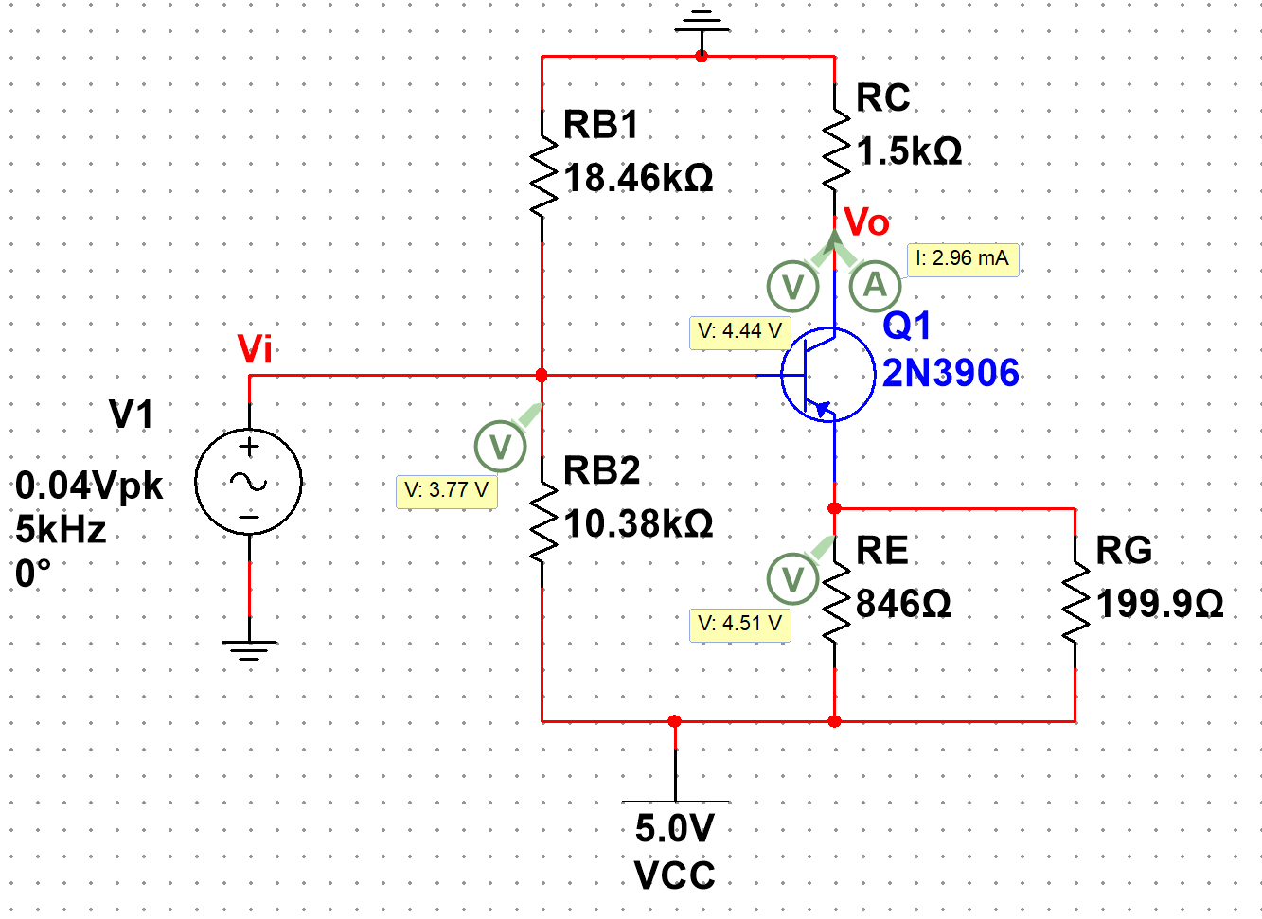

Figure 5: DC solution for Fig. 5(a)

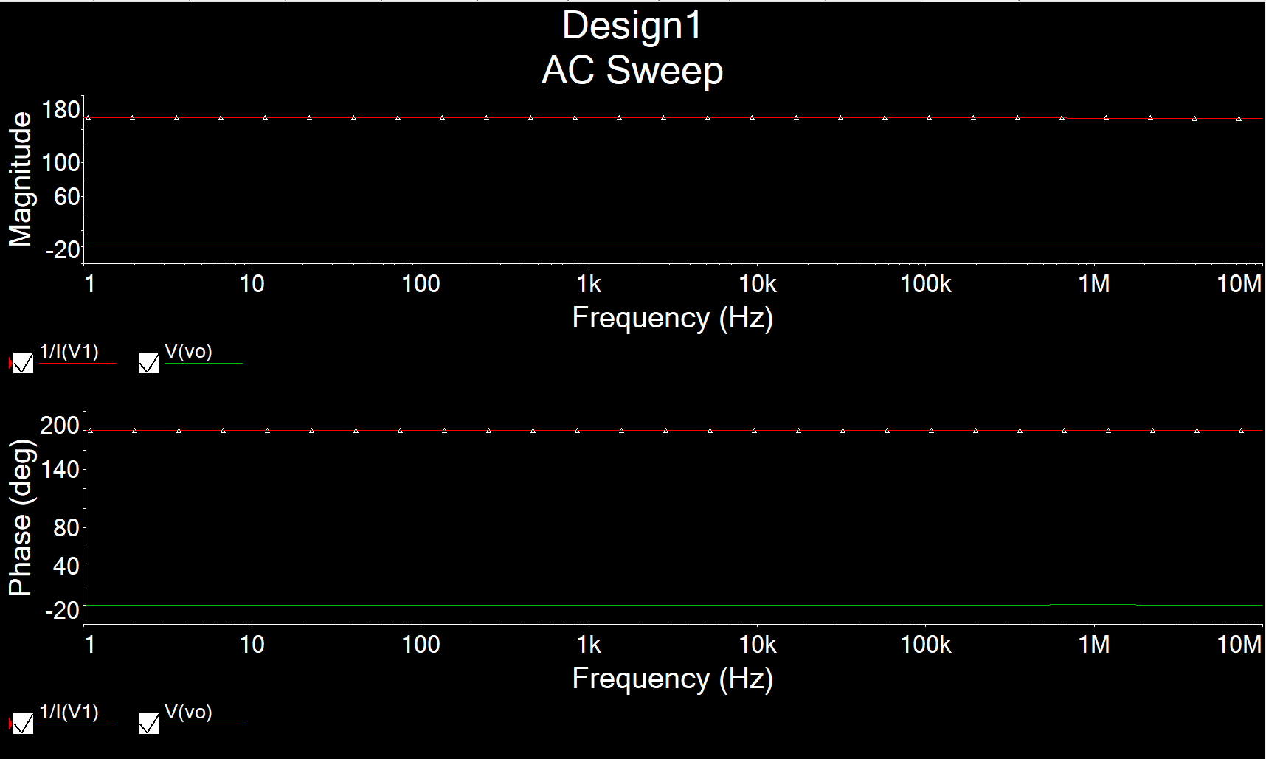

Figure 6: AC Simulation for Av, Ri and Ro for Fig. 5(a)

(Tried to find Av but couldn’t appear on the graph)

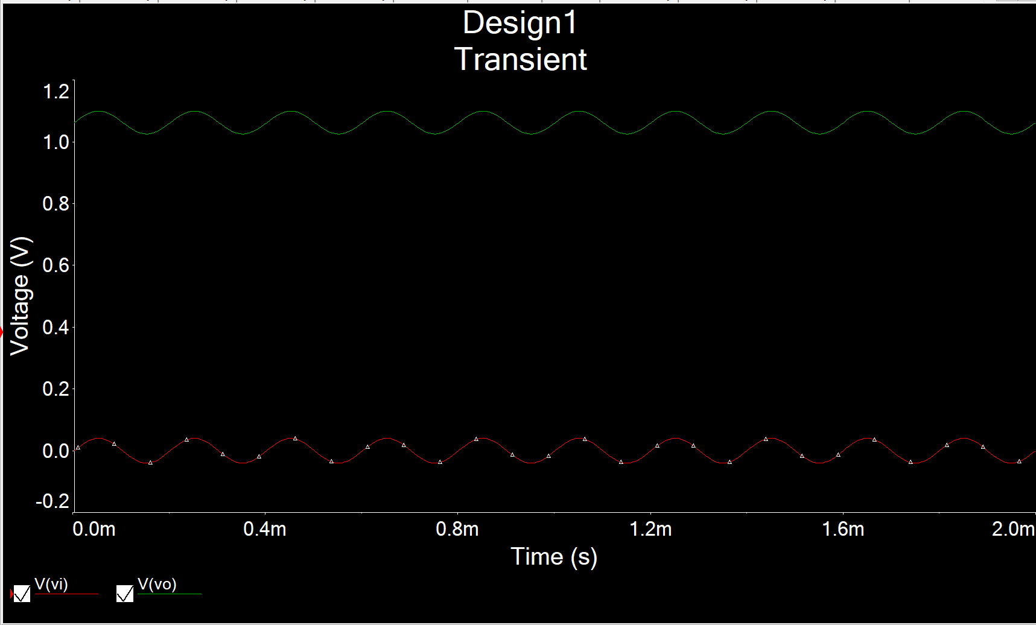

Figure 7: Time-domain Waveform for Fig. 5(a)

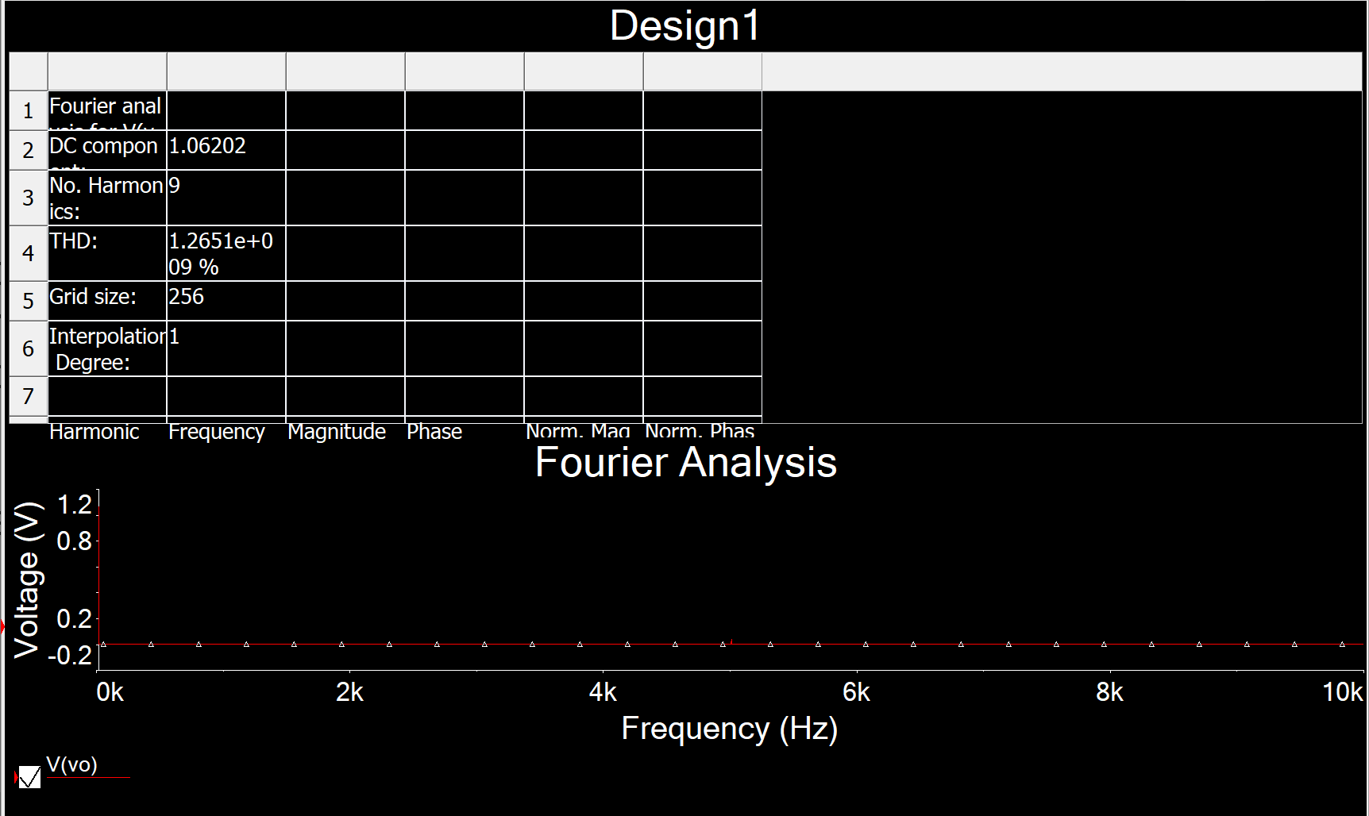

Figure 8: THD Waveform for Fig. 5(a)

**(2)**

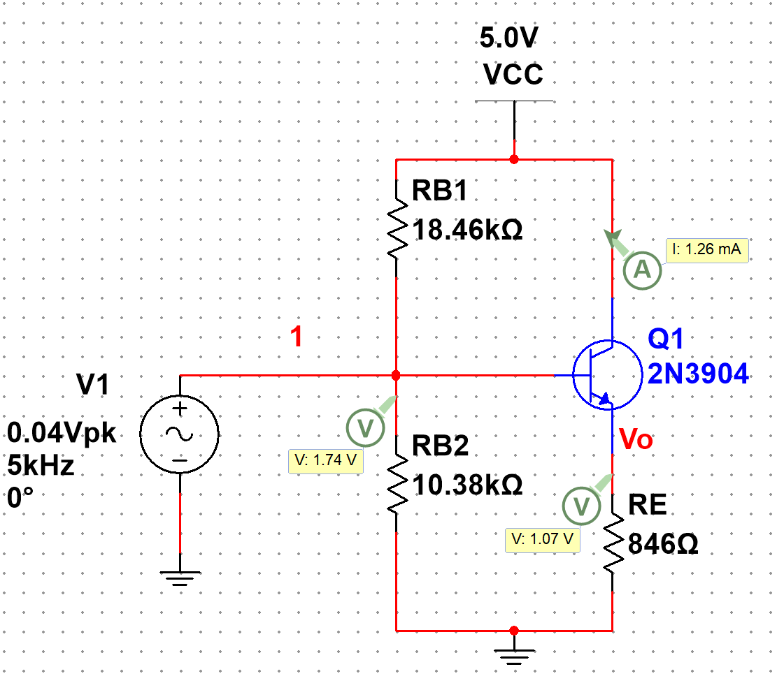

Figure 9: DC solution for Fig. 6(a)

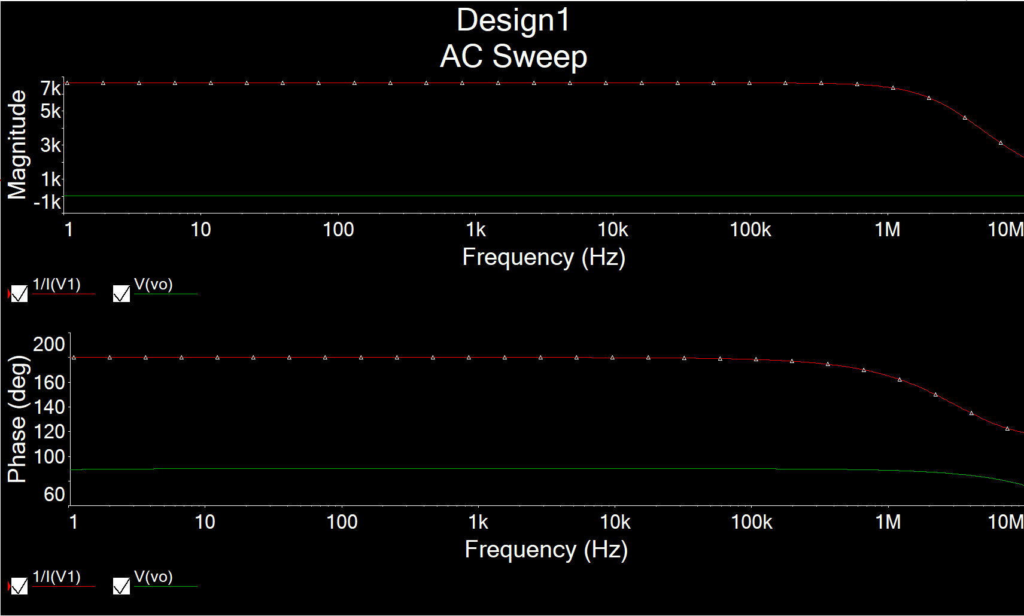

Figure 10: AC Simulation for Av, Ri and Ro for Fig. 6(a)

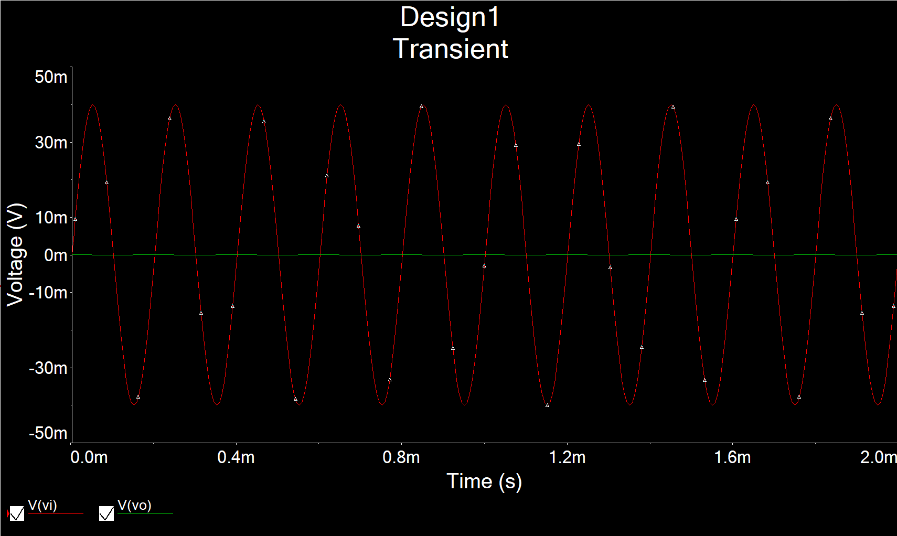

Figure 11: Time-domain Waveform for Fig. 6(a)

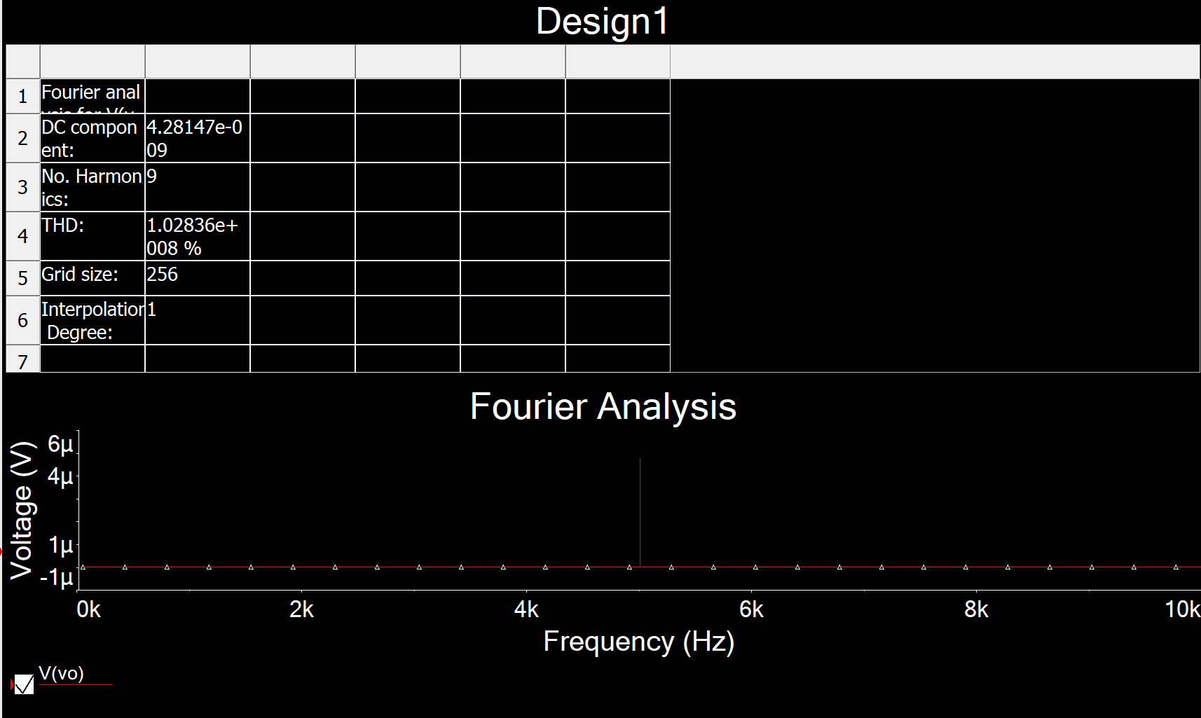

Figure 12: THD Waveform for Fig. 6(a)

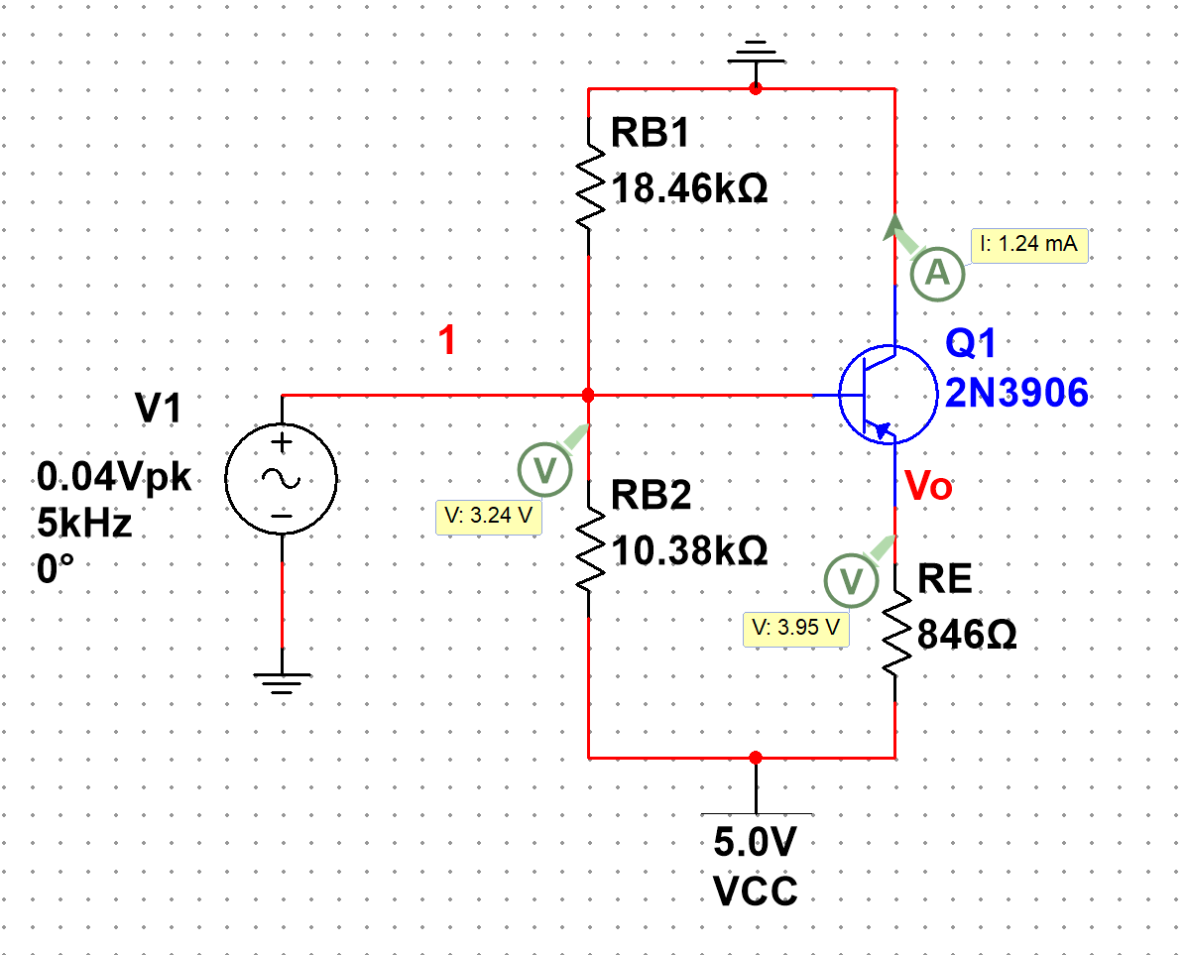

Figure 13: DC solution for Fig. 7(a)

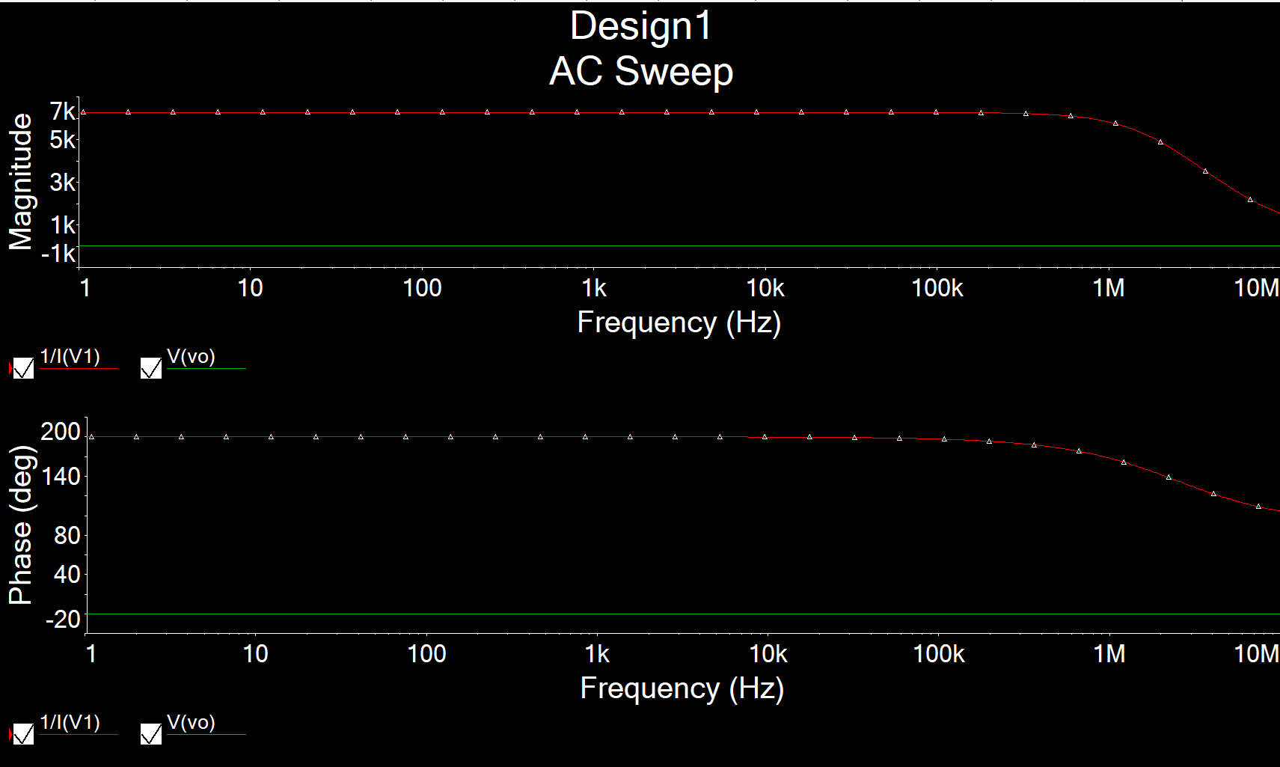

Figure 14: AC Simulation for Av, Ri and Ro for Fig. 7(a)

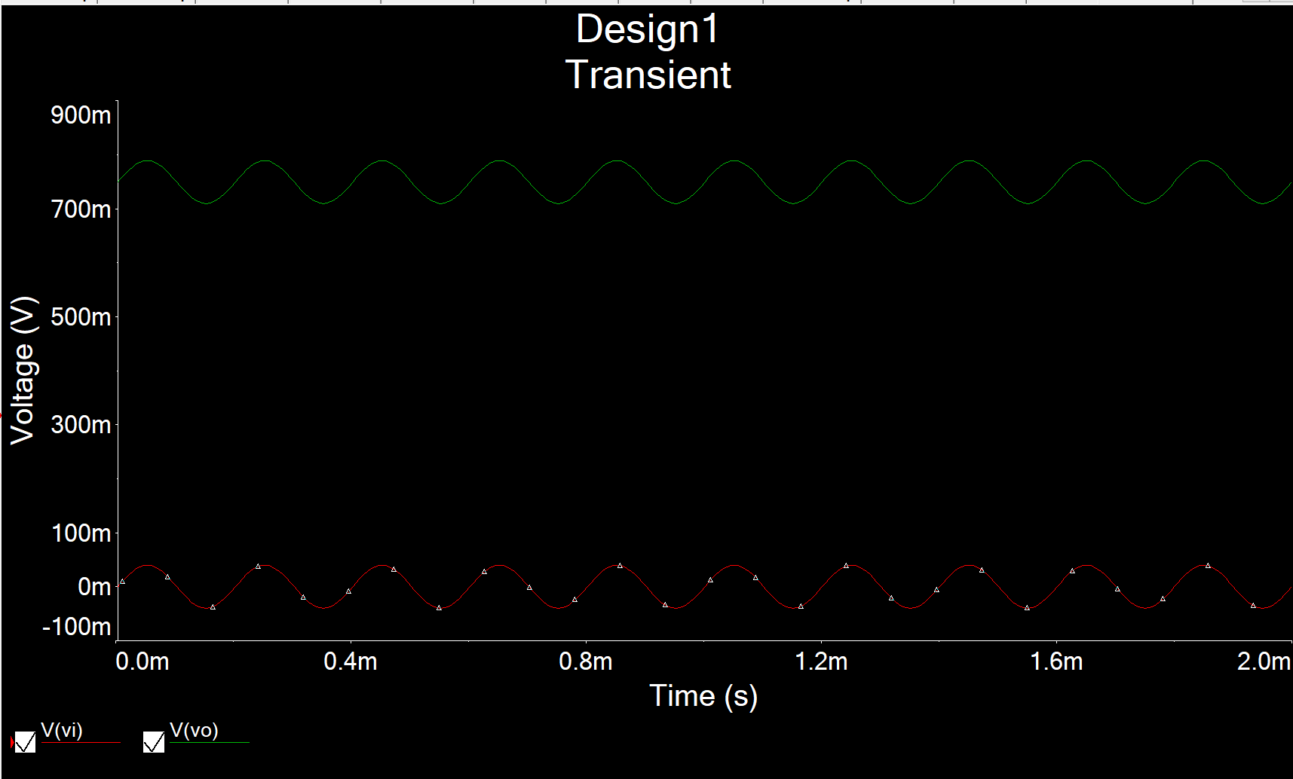

Figure 15: Time-domain Waveform for Fig. 7(a)

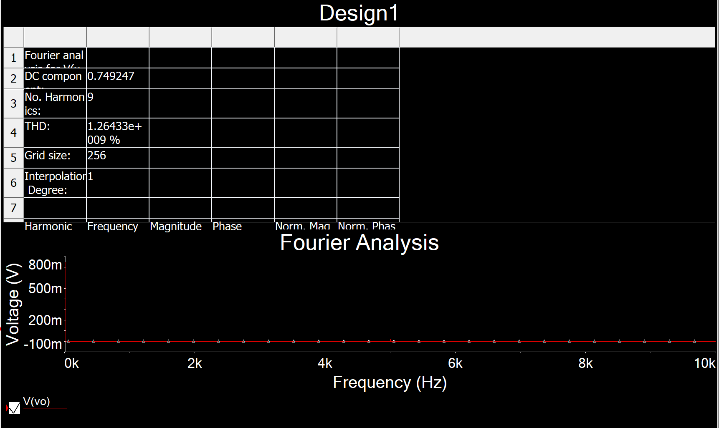

Figure 16: THD Waveform for Fig. 7(a)

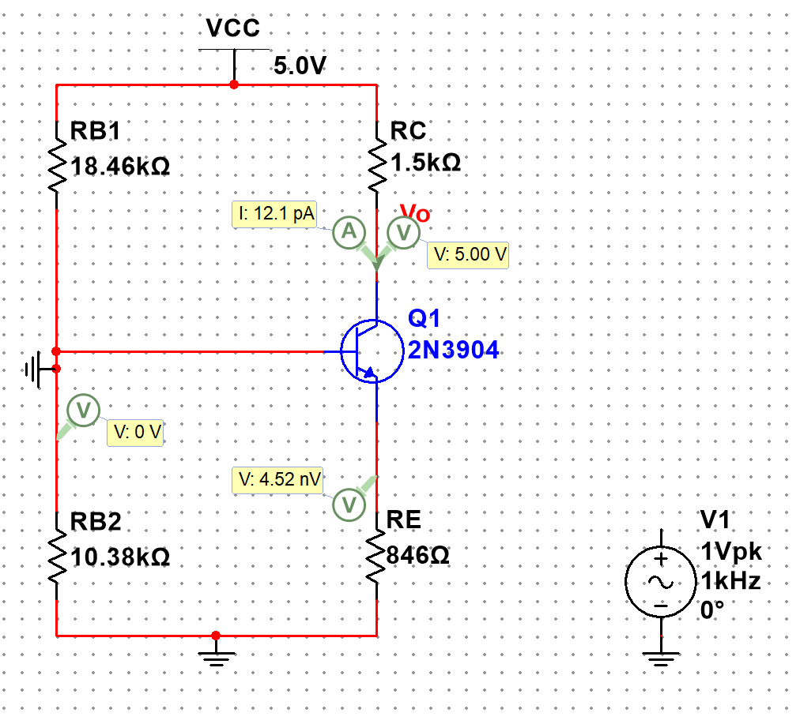

Figure 17: DC solution for Fig. 8(a)

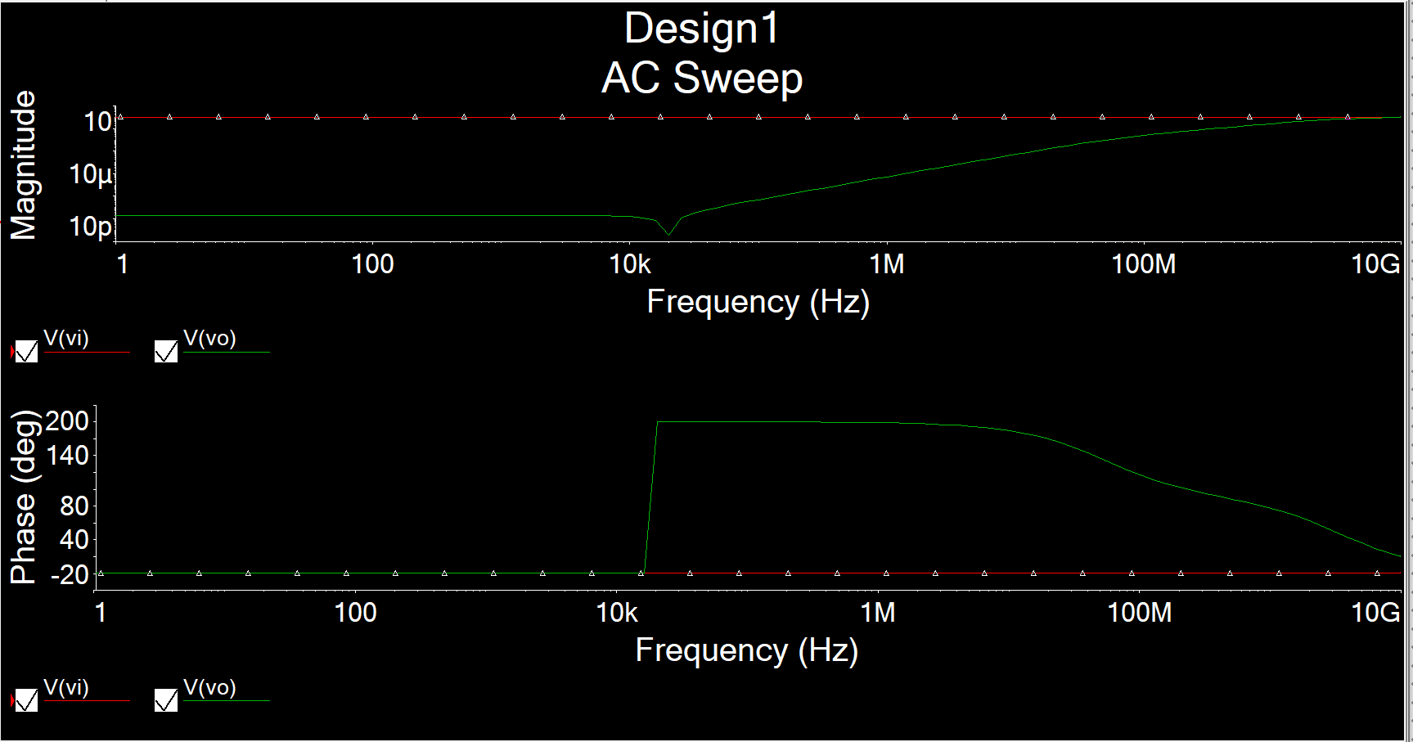

Figure 18: AC Simulation for Av, Ri and Ro for Fig. 8(a)

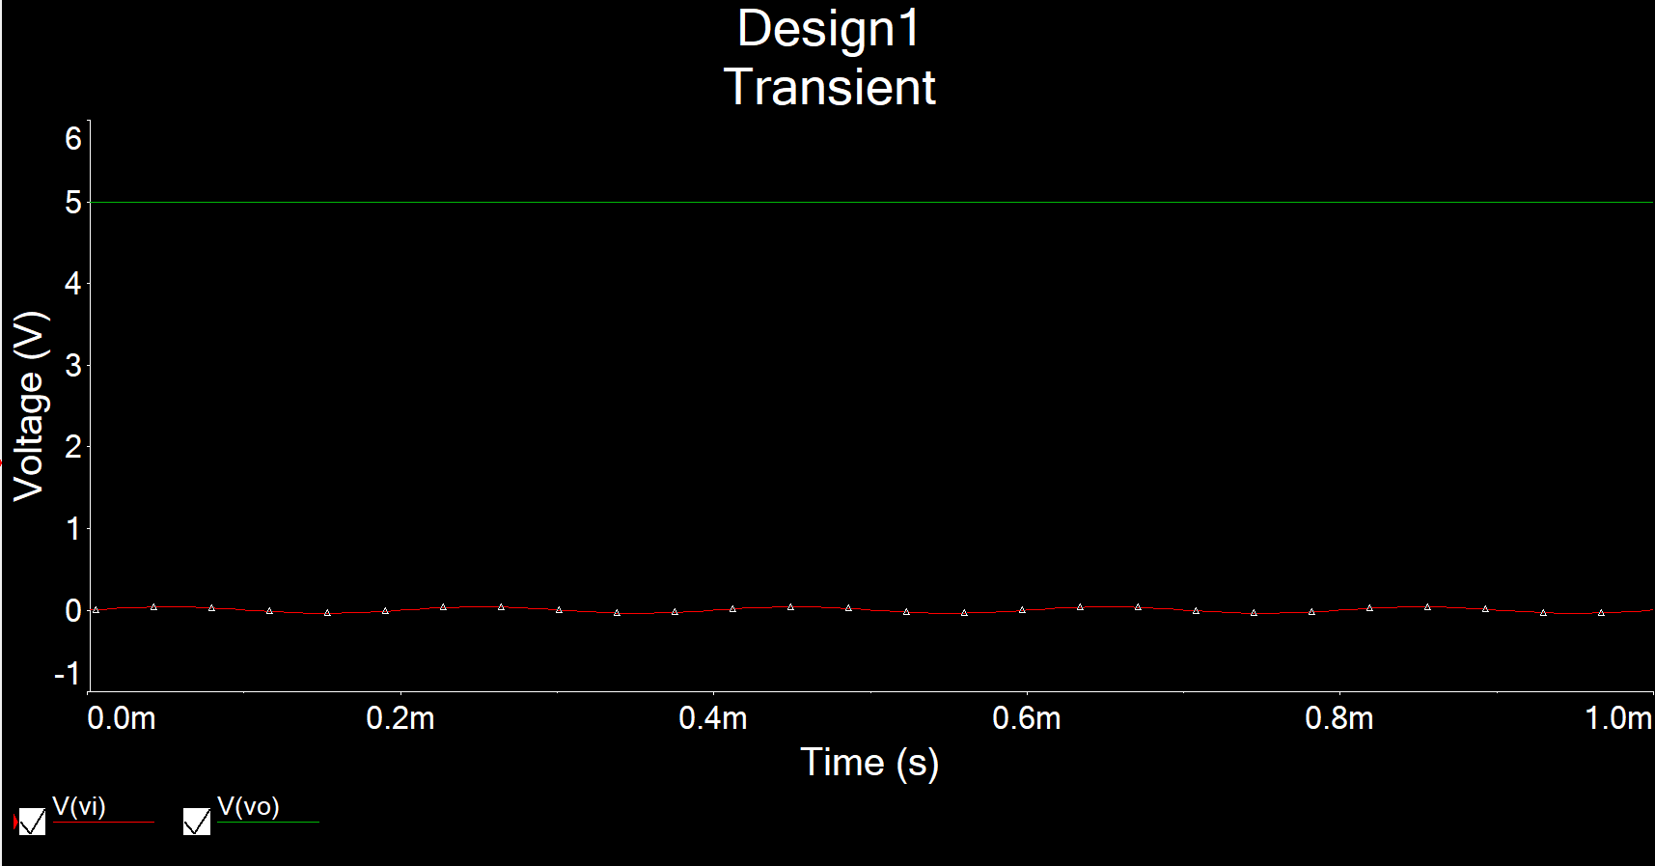

Figure 19: Time-domain Waveform for Fig. 8(a)

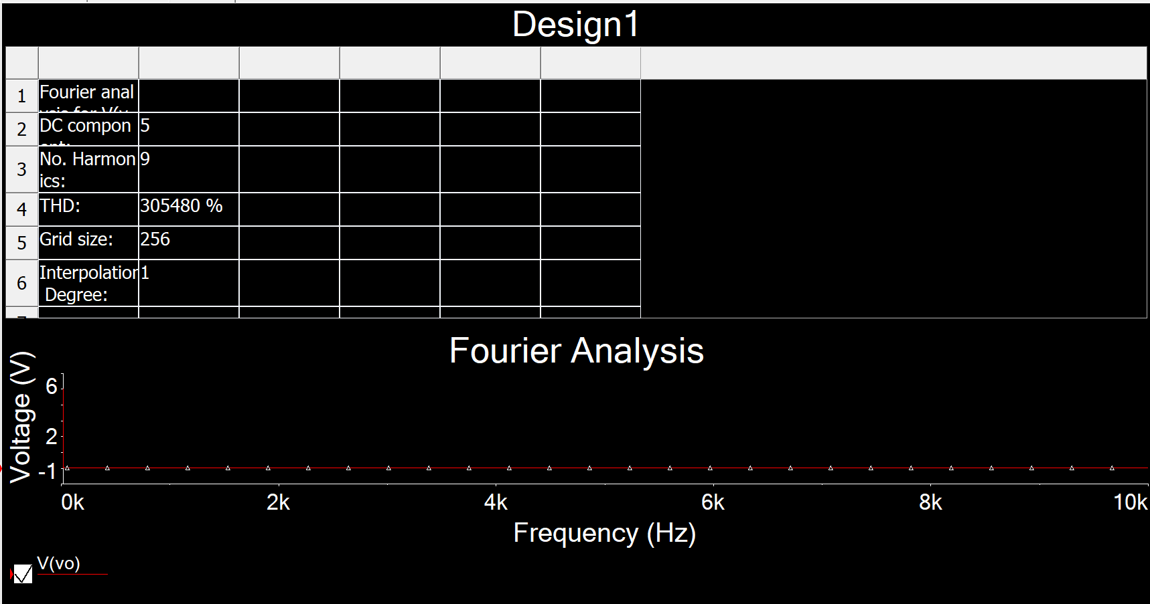

Figure 20: THD Waveform for Fig. 8(a)

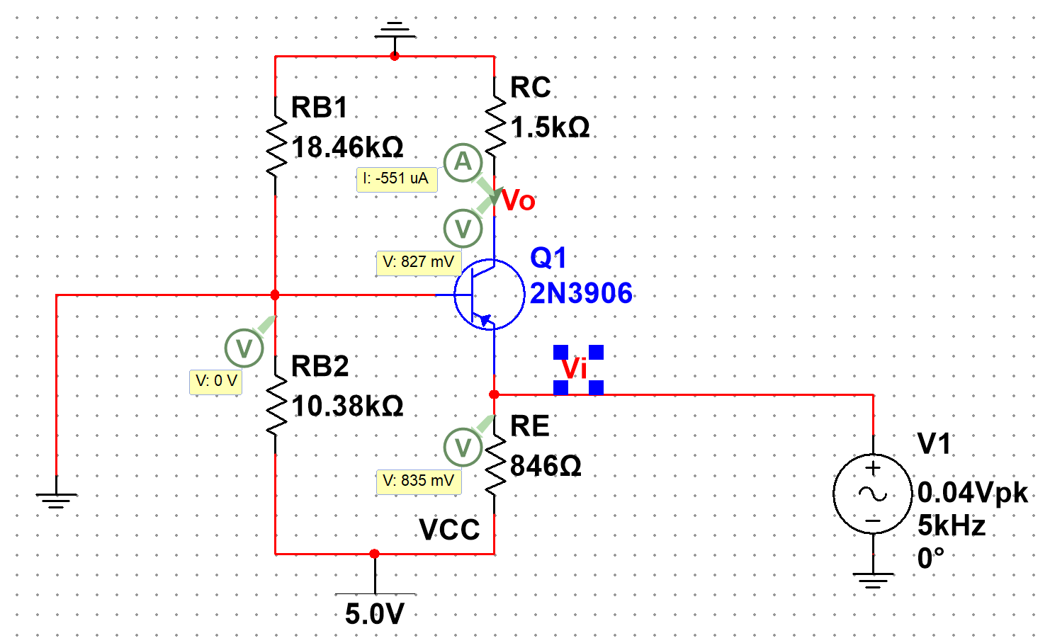

Figure 21: DC solution for Fig. 9(a)

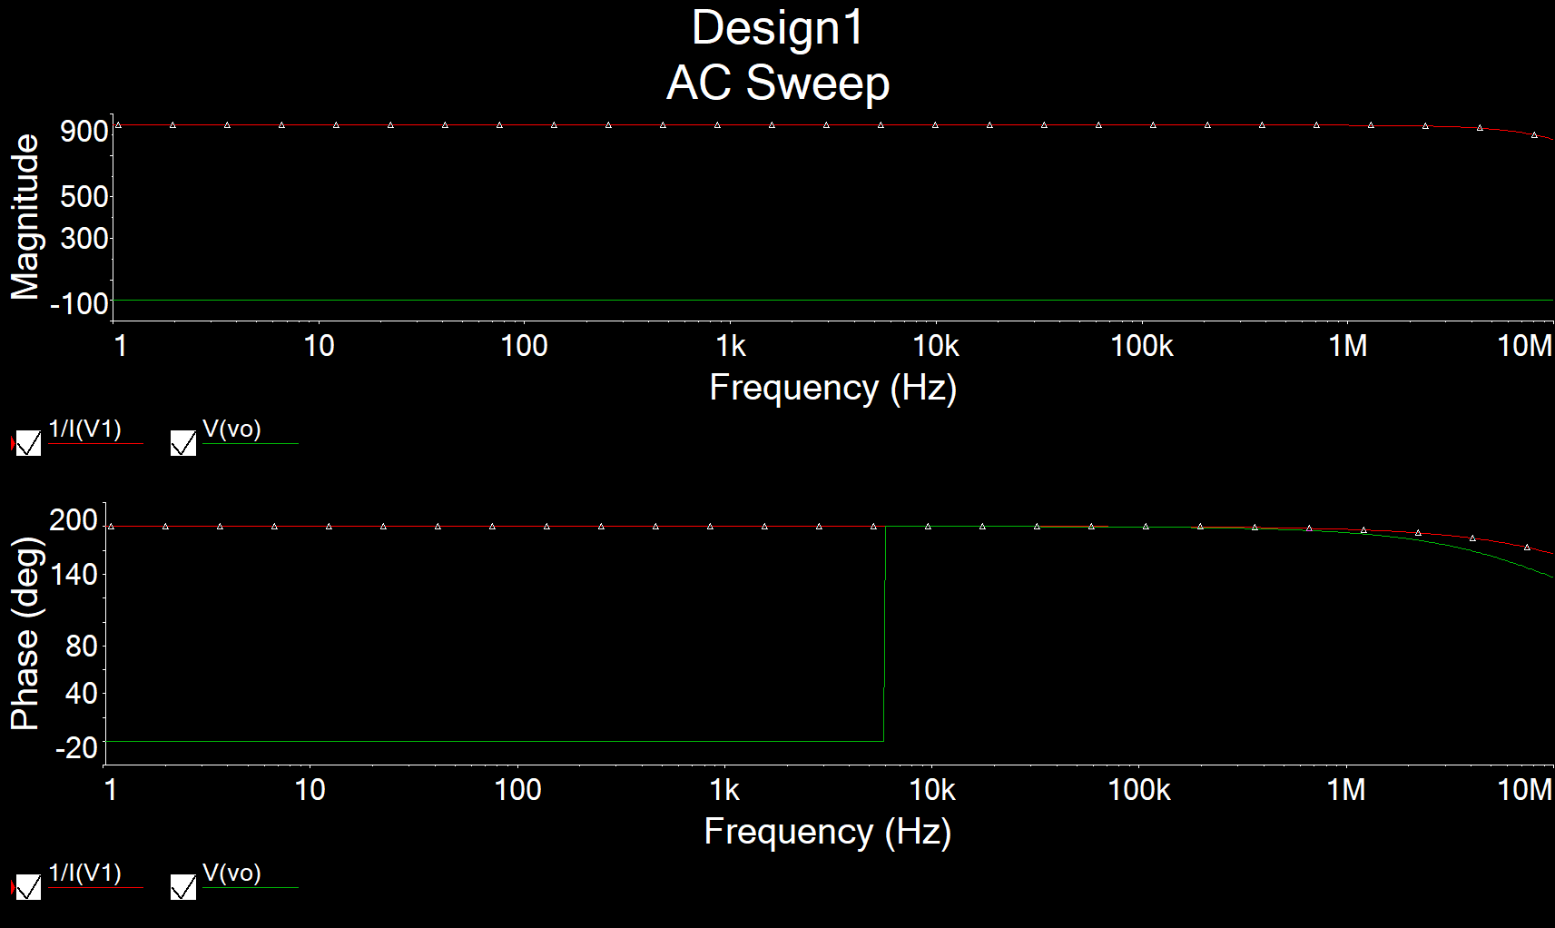

Figure 22: AC Simulation for Av, Ri and Ro for Fig. 9(a)

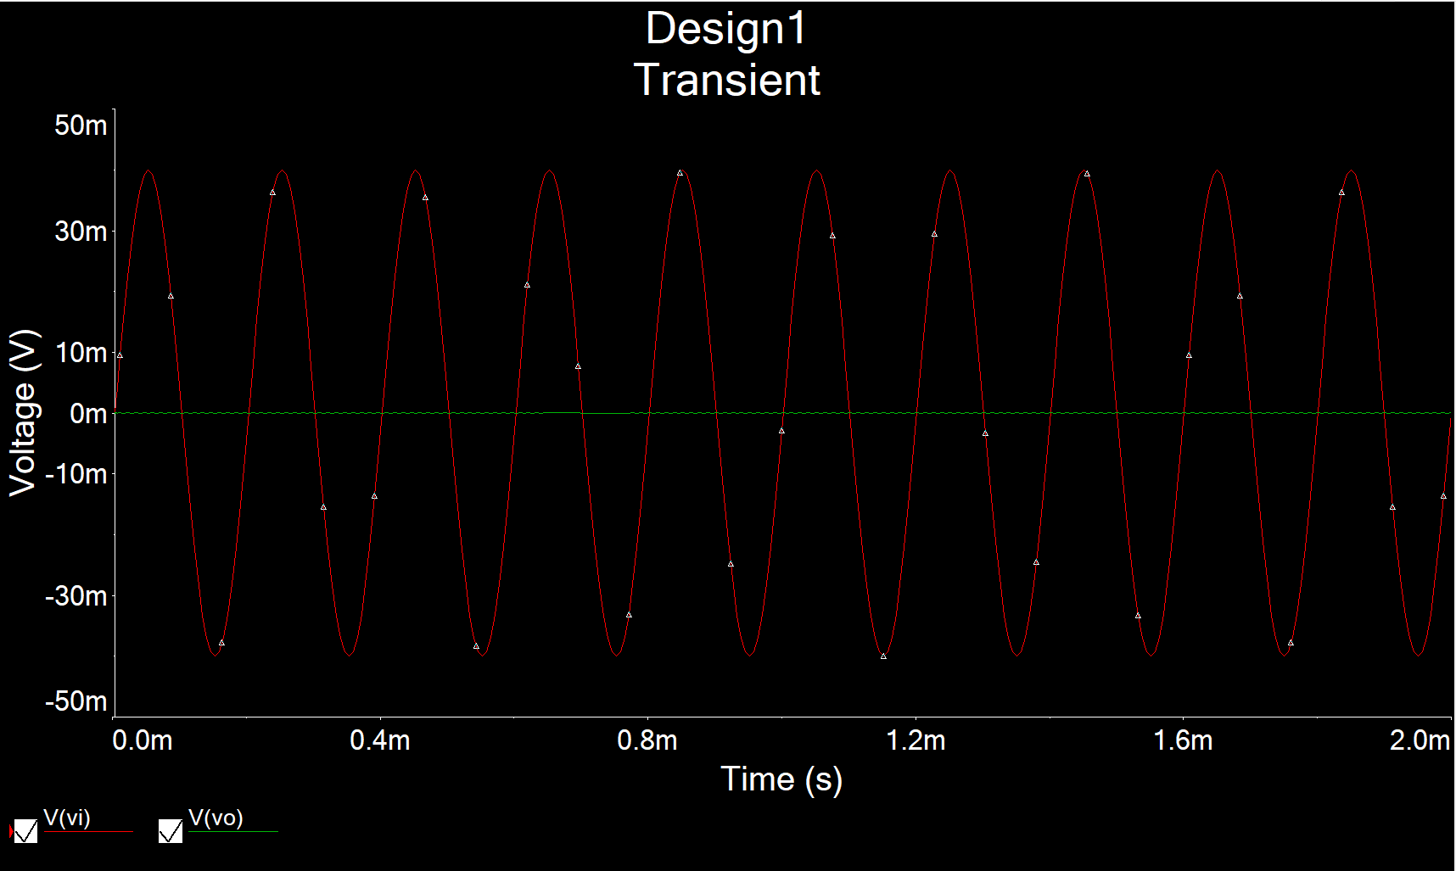

Figure 23: Time-domain Waveform for Fig. 9(a)

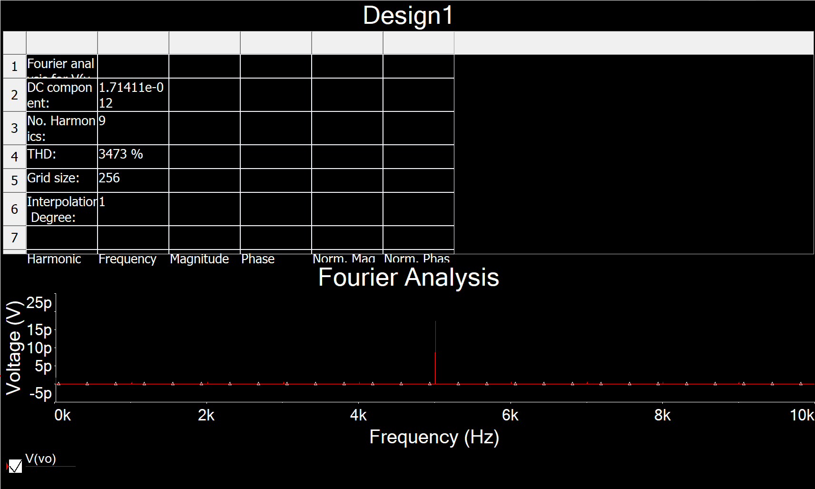

Figure 24: THD Waveform for Fig. 9(a)